REGULAR MEETING
VILLAGE OF MORRILL BOARD OF TRUSTEES
August 12, 2025

A Regular Meeting of the Chairman and Board of Trustees of the Village of Morrill, Nebraska was held on August 12, 2025, at 6:00 p.m. at the Village of Morrill Legion Hall. Notice about the meeting had been published according to law, in the Star Herald, a newspaper published of general circulation in the Village and posted in 3 conspicuous places within the Village of Morrill. The notice stated the date, hour and place of the meeting, that the meeting would be open to the public, that anyone with a disability desiring reasonable accommodation to attend the meeting should contact the Village office, and that an agenda of the meeting kept continuously current was available for public inspection at the office of the Village; provided, however, the Village Board could modify the agenda at the meeting if it determined that an emergency so required. An agenda kept continuously current was always available for public inspection at the Village office from the date of publication of the notice to the time of the meeting. A similar notice, together with a copy of the agenda, was also delivered to each Board Member.

Chairman Hart presided and Clerk Schmidt recorded the proceedings. The Pledge of Allegiance was recited. Hart directed the public a copy of the Nebraska Open Meetings Act, posted on the north wall for the public’s review. The following Board Members were present: Neal Hart, Steve Engleman, David Purviance, Joe Conrad and Kim Schledewitz.

Moved by Member Conrad and seconded by Member Purviance to approve the agenda as presented.
YEAS: Hart, Conrad, Engleman, Purviance, and Schledewitz NAYS: None, ABSENT: None.

Moved by Member Hart and seconded by Member Schledewitz that the minutes from Jul 8, 2025, Regular Meeting and August 7, 2025, Special Meeting be approved. YEAS: Hart, Conrad, Engleman, Purviance, and Schledewitz NAYS: None, ABSENT: None.

Moved by Member Schledewitz and seconded by Member Engleman to approve July 31, 2025, Treasurer’s Report. YEAS: Hart, Conrad, Engleman, Purviance, and Schledewitz NAYS: None, ABSENT: None.

Chairman Hart asked if any citizens with business not scheduled on the agenda wished to include an item providing the Village Board determines the item requires emergency action. There were no emergency items.

Moved by Member Schledewitz and seconded by Member Purviance to approve Karen Laws and Greg Waters to the Library Board. YEAS: Hart, Conrad, Engleman, Purviance, and Schledewitz NAYS: None, ABSENT: None.

Moved by Member Hart and seconded by Member Schledewitz to approve the library to apply for a grant for a little library to be placed in Morrill’s City Park. YEAS: Hart, Conrad, Engleman, Purviance, and Schledewitz NAYS: None, ABSENT: None.

Moved by Member Hart and seconded by Member Purviance to waive the 3 readings for Ordinance D-382 to set salaries for employees and Trustees. YEAS: Hart, Conrad, Engleman, Purviance, and Schledewitz NAYS: None, ABSENT: None. Moved by Member Hart and seconded by Member Conrad to Adopt Ordinance D-382. YEAS: Hart, Conrad, Engleman, Purviance, and Schledewitz NAYS: None, ABSENT: None.

ORDINANCE D-382
AN ORDINANCE AMENDING ORDINANCE D-377
AN ORDINANCE ESTABLISHING SALARIES FOR OFFICERS AND EMPLOYEES OF
THE VILLAGE OF MORRILL
Published in Pamphlet Form.

Discussion was held regarding the Adoption of a Resolution to Change the Employee Manual/Policies to a Zero Tolerance Policy and including all Employees in the Drug Testing at the July meeting. When Clerk Schmidt contacted WPCI there was going to be a substantial cost to the Village that needed to be done within 30 days by drug testing all current non-DOT employees. This amount was not in the current budget and along with the WPCI fees the amount would cost the Village approximately $4,000.00. Moved by Member Conrad and seconded by Member Purviance to Reconsider Resolution 25-06 so that we can budget for the additional costs. The Resolution will be brought back at the September meeting with an effective date of October 1, 2025, for consideration. YEAS: Purviance, Conrad, Engleman and Schledewitz NAYS: Hart, ABSENT: None.

Moved by Member Hart and seconded by Member Schledewitz to Adopt Resolution 25-07 Nebraska Board of Public Roads Classifications and Standards and approve Annual Certification of Program Compliance. YEAS: Hart, Conrad, Engleman, Purviance, and Schledewitz NAYS: None, ABSENT: None.

Fire Chief Matt Hinman shared a Fire Department Cadet Program Guideline and Structure program for consideration. They are looking to have certain fire members partner with 17- to 18-year-olds at the Morrill High School. The students would be able to attend meetings, run drills and learn the basic firefighting skills. The item will be placed on the September agenda to allow the board and legal counsel to read over the proposal.

An opportunity for public comment was provided. Public comments were as follows: Pete Cawiezel shared that the yard of the week has two weeks left. Joe Conrad shared that he loved that the church received yard of the week this week. The property has come a long way and looks great. Pete also thanked the board and read a statement about the Village of Morrill. There is a huge support system here within the residents of Morrill and genuine caring. Though things will look different moving forward with Rendezvous Days, Pete shared that he is committed to the community. Clerk Schmidt thanked Pete for continuing the yard of the week program.

The Village Board then received written reports from departments.

The next item on the agenda was the approval of bills and expenses. It was moved by Member Schledewitz and seconded by Member Hart to approve all claims as presented.
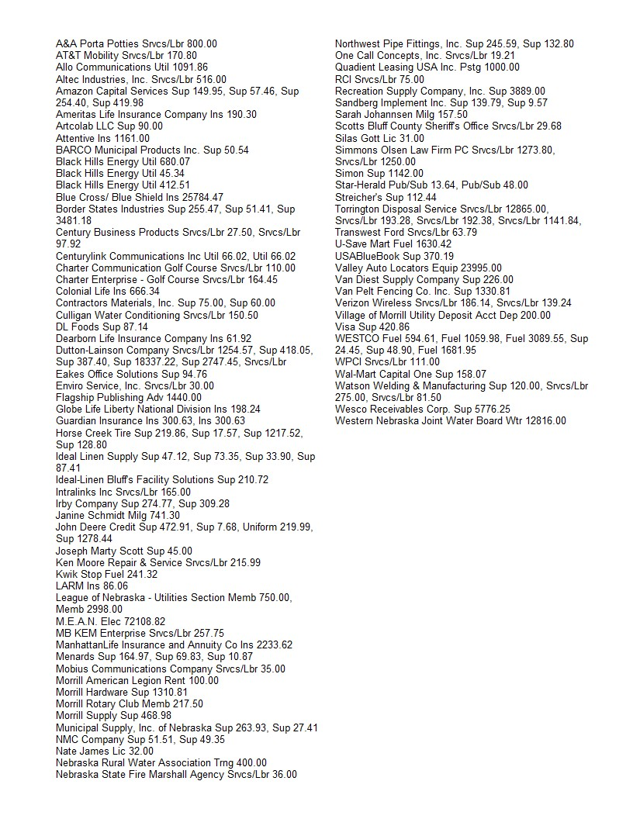

YEAS: Hart, Conrad, Engleman, Purviance, and Schledewitz NAYS: None, ABSENT: None.

The next Regular Board of Trustee Meeting will be held on September 9, 2025, immediately following the Public Hearings for the Tax Ask, 25-26 Budget and 1- & 6-Year plan at the Morrill American Legion.

The last item on the agenda was a motion to adjourn by Member Conrad and seconded by Member Schledewitz. YEAS: Hart, Conrad, Engleman, Purviance, and Schledewitz NAYS: None, ABSENT: None.
.
The meeting was then adjourned at 6:33 p.m.

/s/ Janine K. Schmidt /s/ Neal Hart
Janine K. Schmidt Neal Hart
CMC/Treasurer Chairman, Board of Trustees

